Overview of Your Study Experiences

# What This Report Shows

Thank you for participating in this study. This report summarizes what you shared with us about your experiences, feelings, symptoms, and daily life over the weeks. **There are no right or wrong answers**.

## 📆 Daily Questionnaires

Here, you will see a summary of the answers you provided in the **daily questionnaires**, which you completed **three times a day for 90 days**.

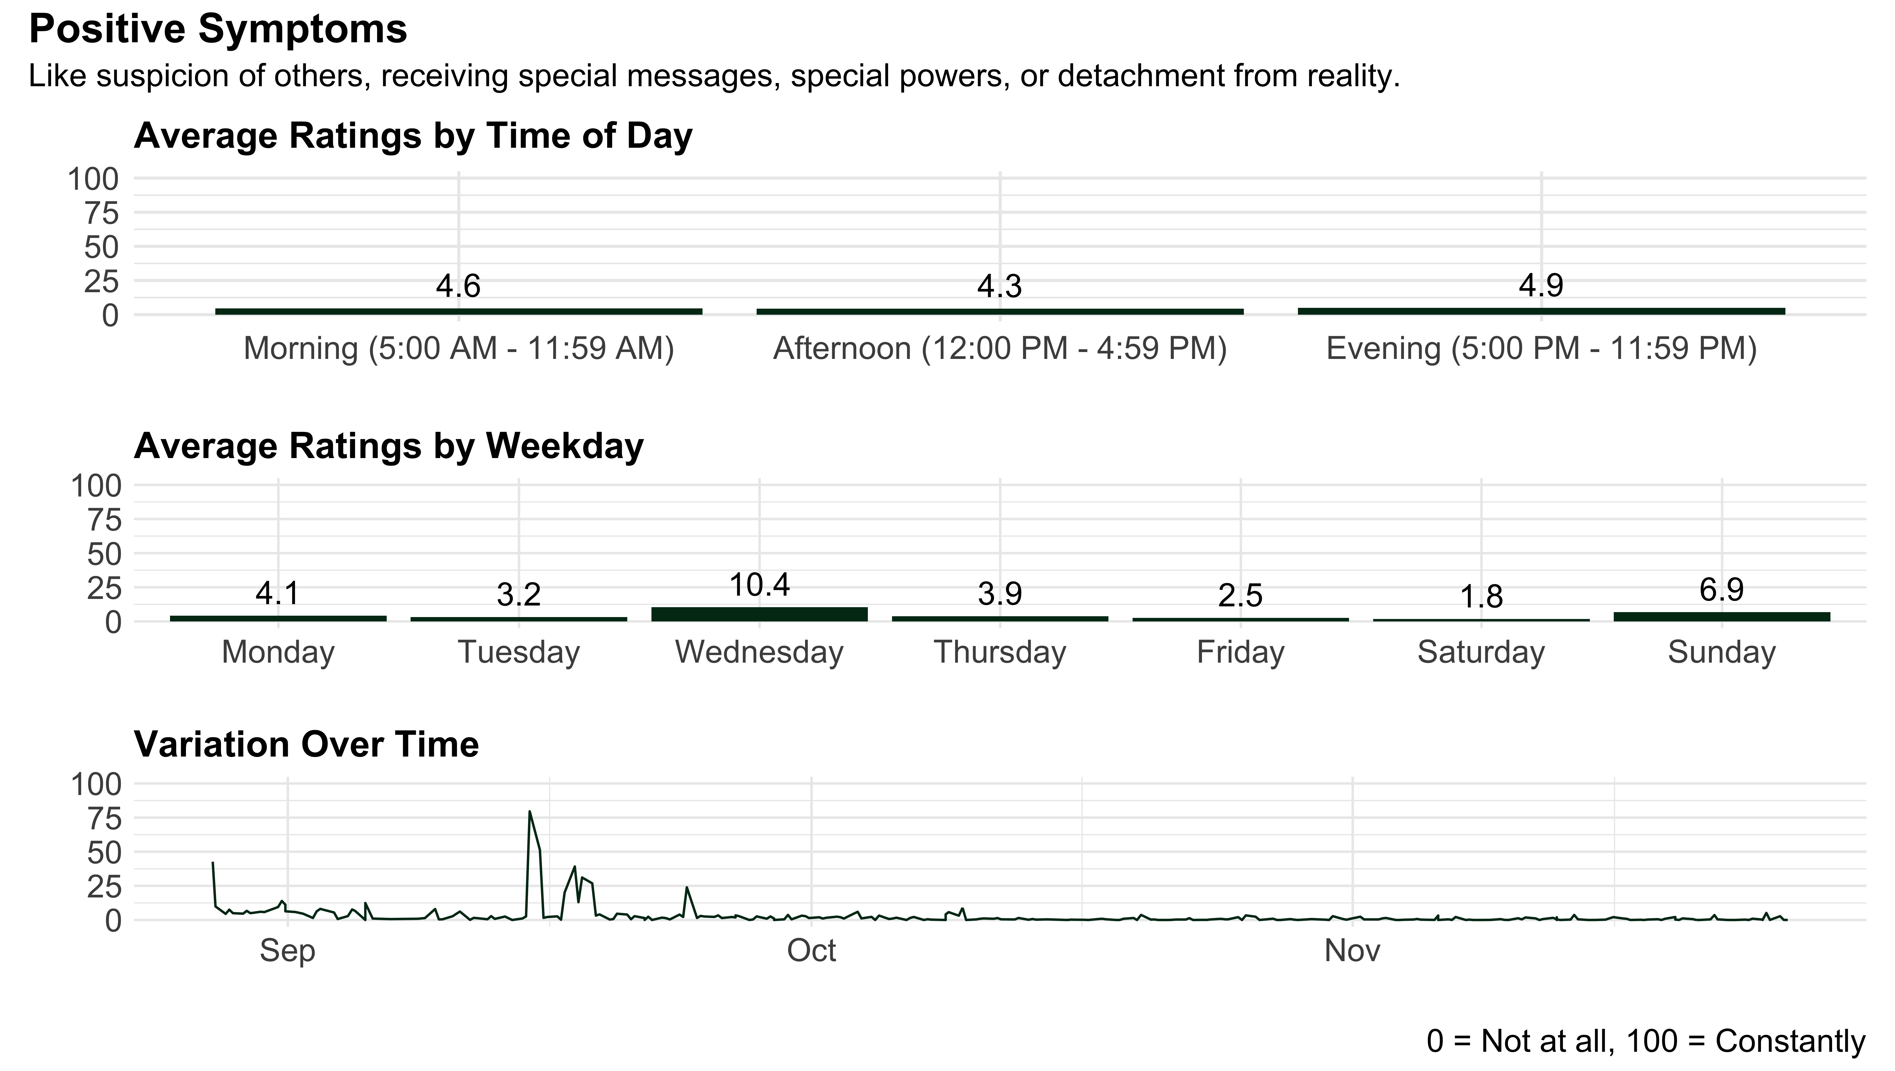

#### Average Ratings by Question (Over the Past 4 Hours)

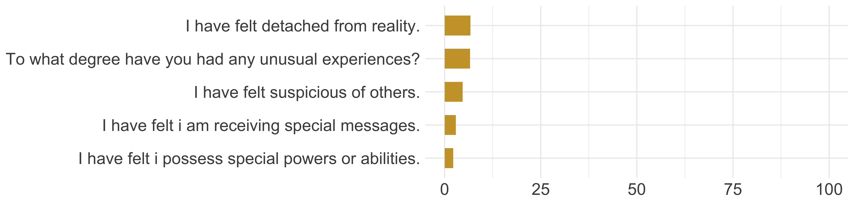

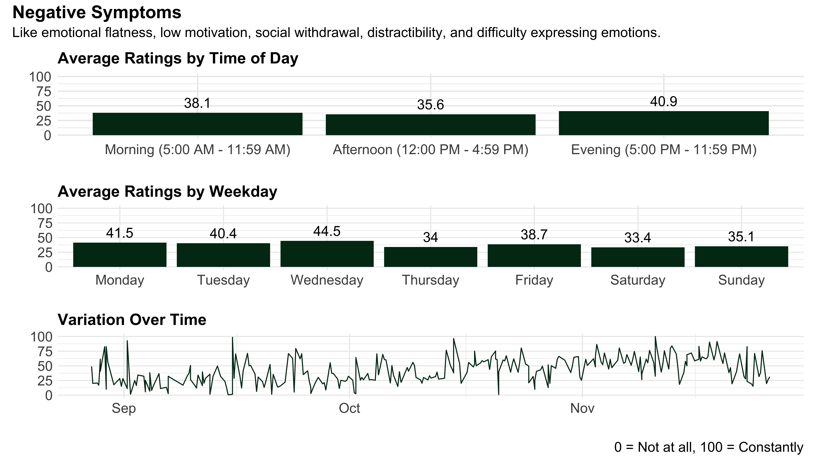

#### Average Ratings by Question (Over the Past 4 Hours)

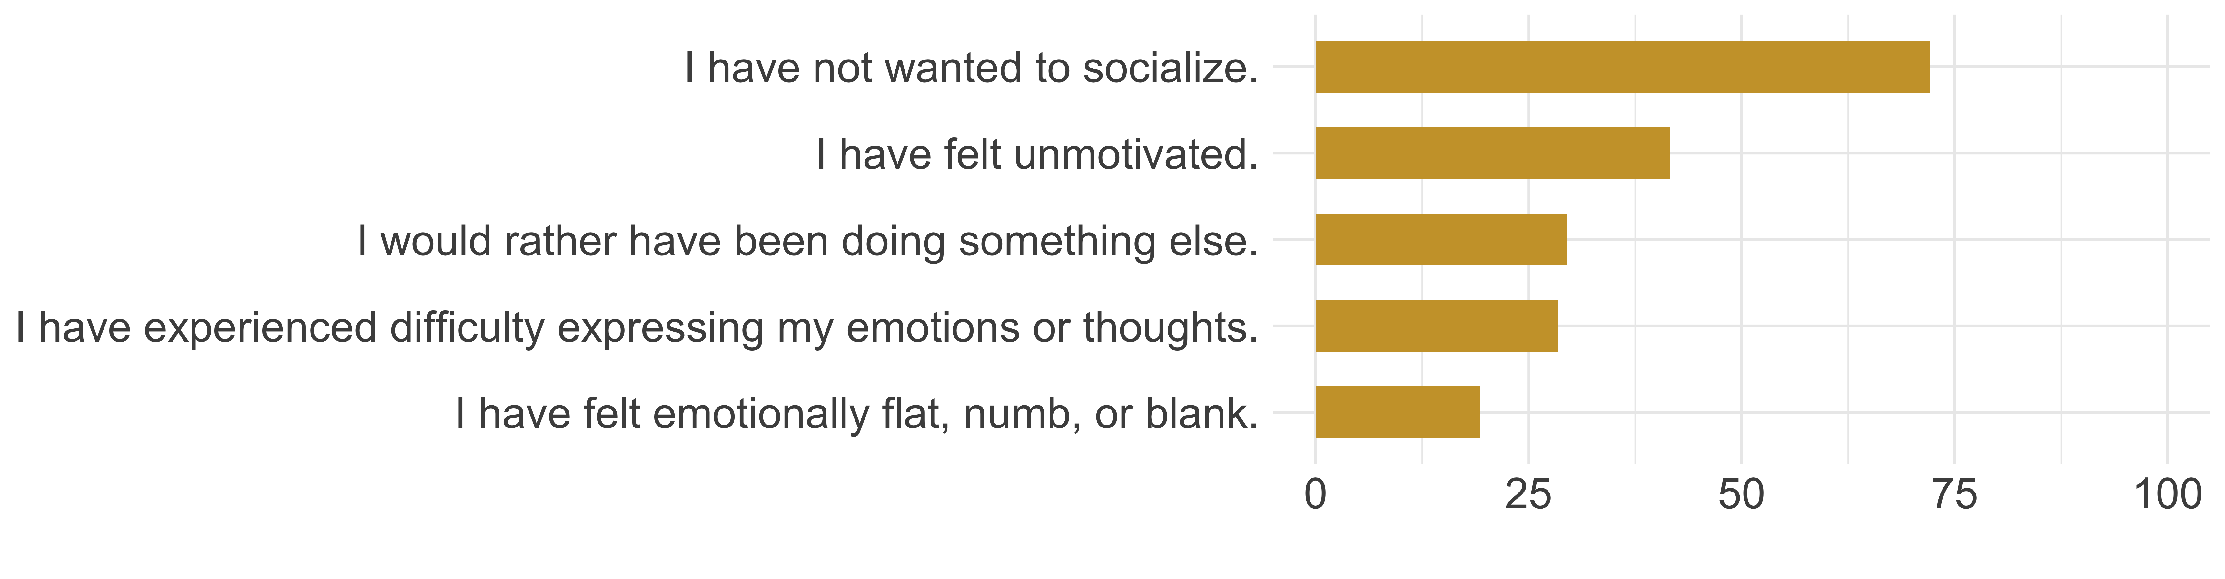

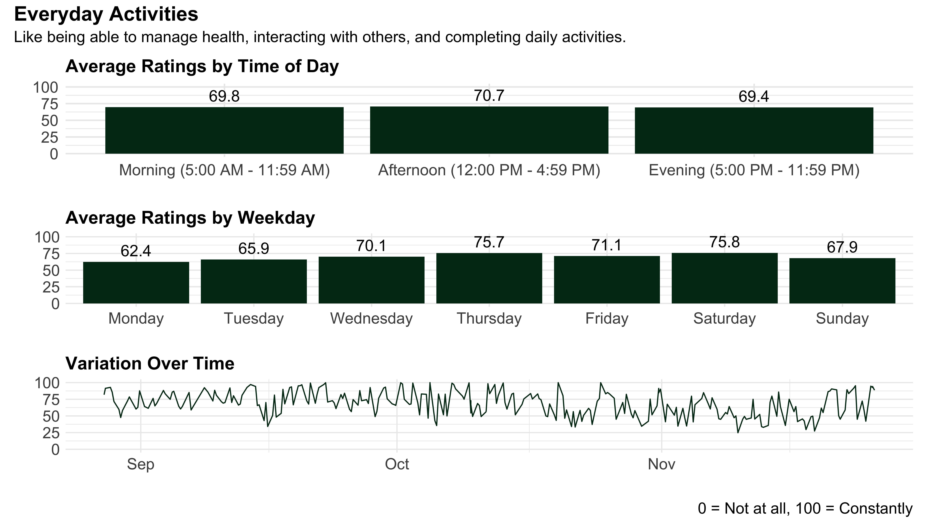

#### Average Ratings by Question (Over the Past 4 Hours)

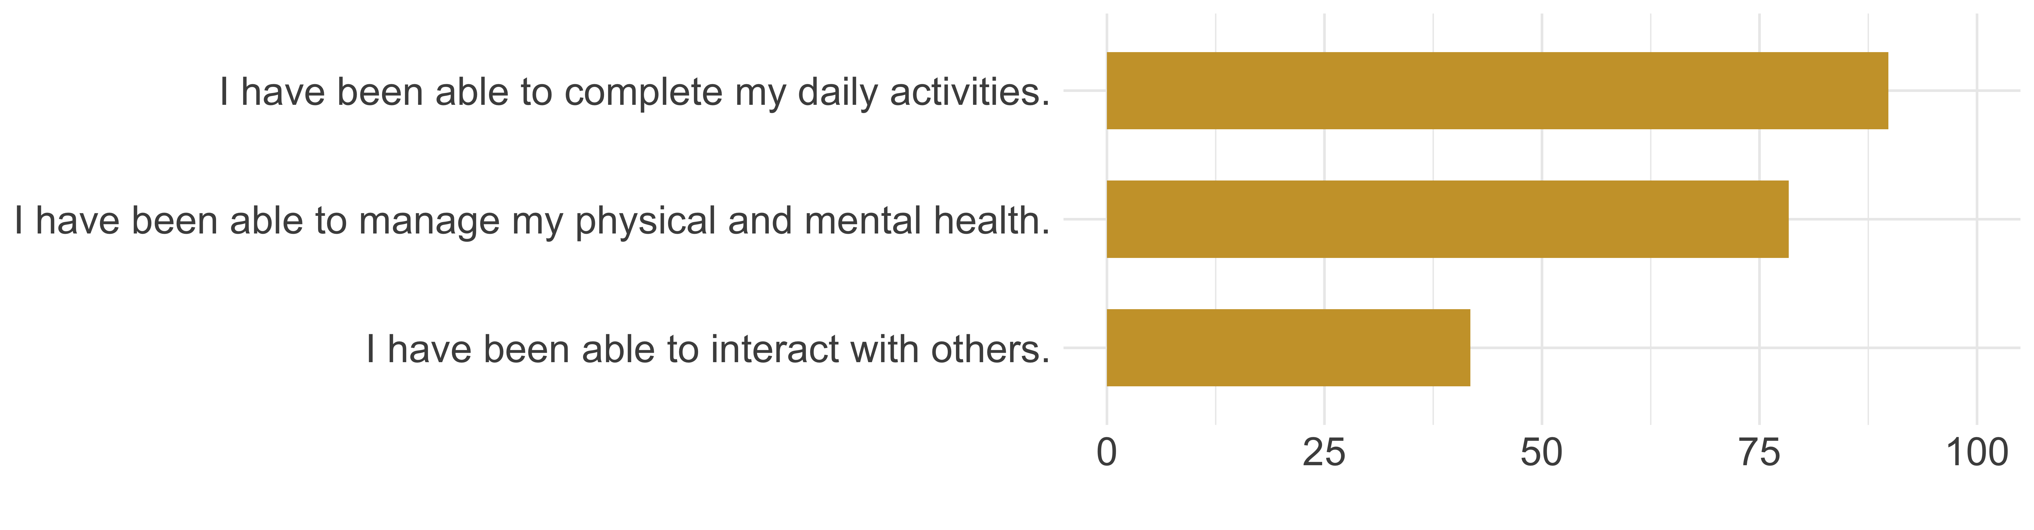

### 🌙 Sleep

You told us about your sleep quality by rating how much trouble you had sleeping last night. On average, you rated your trouble sleeping as **61 out of 100**.

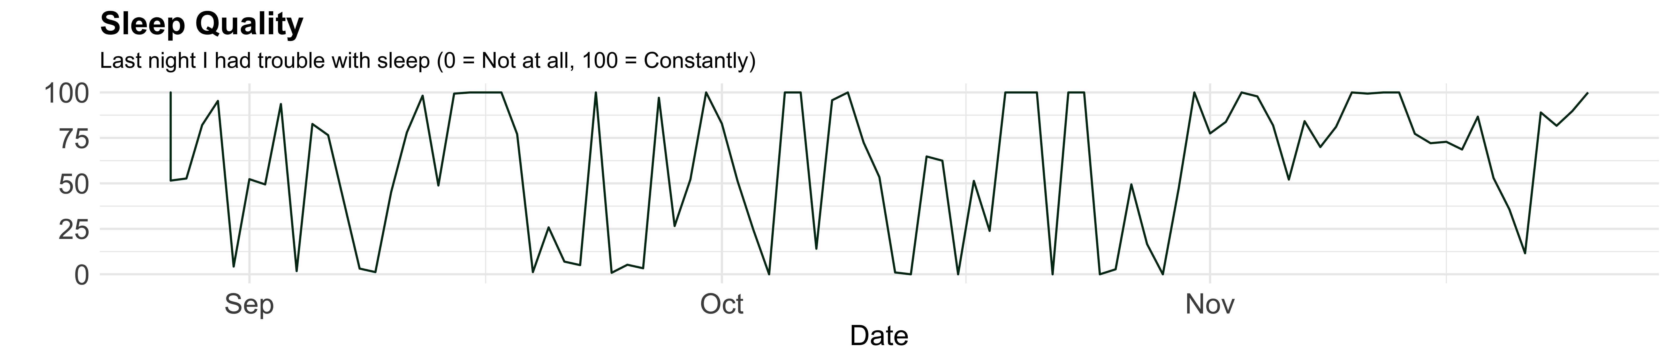

## 📅 How You Felt Each Week

Throughout the study, you filled out **weekly questionnaires**. This section summarizes which answers you gave.

#### Positive Emotions

First, we will look at your positive emotions throughout the past few weeks. Across all weeks, the strongest positive emotion reported was **Alert**. The weakest average emotion was **Active**.

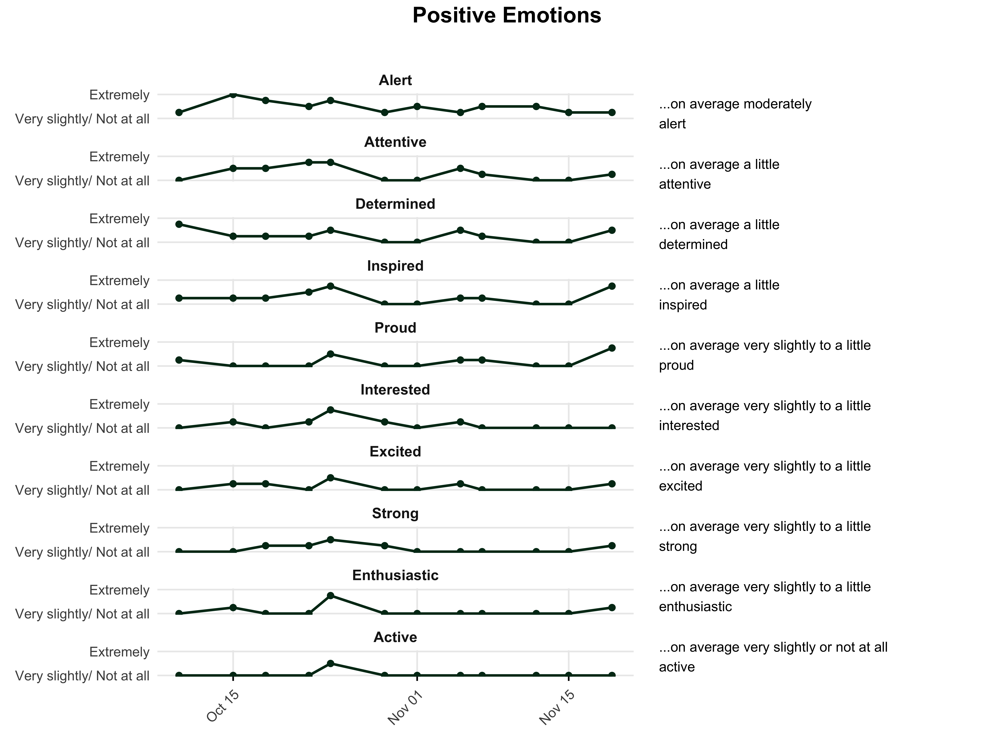

#### Negative Emotions

Now we will look at your negative emotions during the past few weeks. Across all weeks, the strongest negative emotion reported was **Guilty**. The weakest average emotion was **Hostile**.

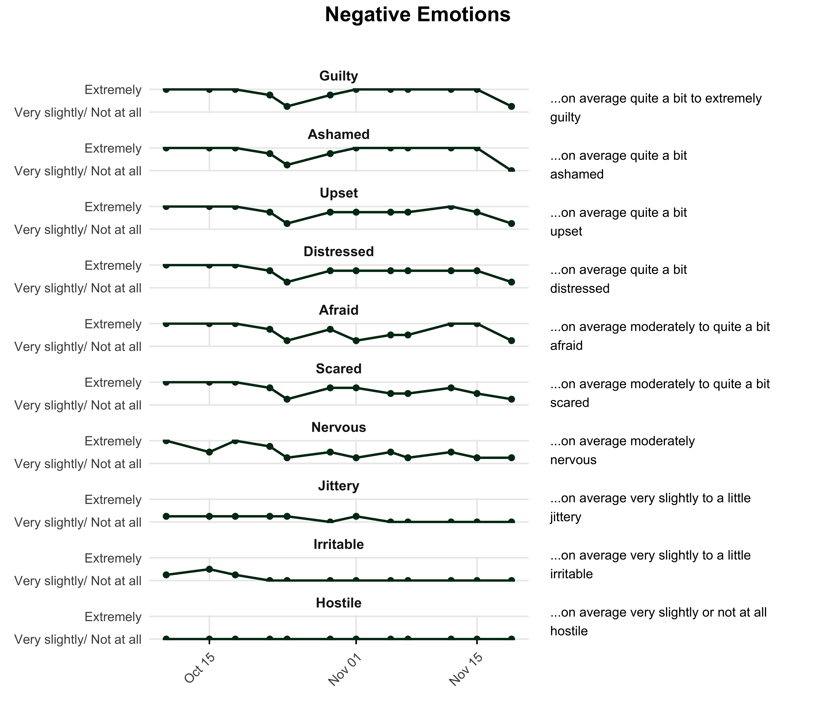

### Your Weekly Life Events

Each week, we asked you to share both positive and challenging experiences. Below is a summary of the types of events you reported **over all study weeks** and how frequently they came up. Words that appear larger were mentioned more often.

